

|  |  |
| --- | --- |
| ***Piercing EYE***  Assisted Face-to-Face Review Expert  in Credit Scenarios | **Introduction to FinTech**  **Business Case Project**  Proposal on FinTech Applications and Disruption  **Name: Kai Ren**  **ID: 2401212437**  **Instructor: Joanna Wang**  **Nov, 4th, 2024** |

***Piercing EYE*: Assisted Face-to-Face Review Expert in Credit Scenarios**

**Name:** Kai Ren **ID:** 2401212437

At a time when the scale of credit is growing and financial risk control is becoming stricter and stricter, the face-to-face examination has become a crucial part of credit approval. A comprehensive, face-to-face review of the applicant's credit status, repayment ability, and loan usage helps the lenders accurately identify user characteristics, assess borrowing risks, and reduce the likelihood of erroneous credit issuance, effectively reducing the rate of bad debt and bankruptcy risk. However, there are currently **three core pain points** in the field of credit face-to-face examination: (1) **Inaccurate.** The scale of professional loan fraudsters is huge, and traditional technical means have many drawbacks, and there is a lack of effective technical empowerment in the face-to-face examination; (2) **Not affordable.** Poor compatibility of existing technical equipment and high data costs make it difficult for small and medium-sized organizations to afford. (3) **Too slow.** The solidification of the approval process and the inefficiency of data processing have greatly affected the speed of credit approval. All these difficulties seriously hinder the efficient face-to-face review of various borrowing institutions. Based on this, I designed and proposed my product, ***Piercing EYE***, which is dedicated to assisting the face-to-face review process in credit scenarios. Aiming at solving the above three core pain points, this product uses a combination of **multimodal data fusion and integration**, **comparative federated learning**, and other related technologies, to improve the accuracy of the assisting model, reduce the requirements of interviewing equipment and data costs, and optimizing the efficiency of the approval system at the same time. By comparing with all kinds of related competitors in the market, it can be seen that **this product has the advantages of multimodal, favorable price, and reliable effect**, which can realize all-around transcendence and has strong competitiveness. Based on the product technology, I also further conceptualized the business model and expected to take software development and sales as the core business, and at the same time make profits through supporting technical services and customized solutions and other businesses.



**Ⅰ. Product and Technology**

* 1. **Market Background**
     1. ***The Scale of Credit is Growing***

Statistics from the People's Bank of China (PBOC)[1] show that the volume of credit transactions in China has grown year on year over the past five years, reaching over 300 trillion RMB by 2023, with an average annual growth rate of nearly 40%. The CEIC database[2] forecasts the total volume of credit in China over the next four years and judges that the volume of credit will continue to grow, reaching nearly 500 trillion RMB in 2027. These numbers show that China's credit market has boomed over the past few years and will continue to have strong growth momentum in the future as well. Therefore, how to issue loans efficiently and safely, control the bad debt rate, and prevent and control financial risks has become a key issue.

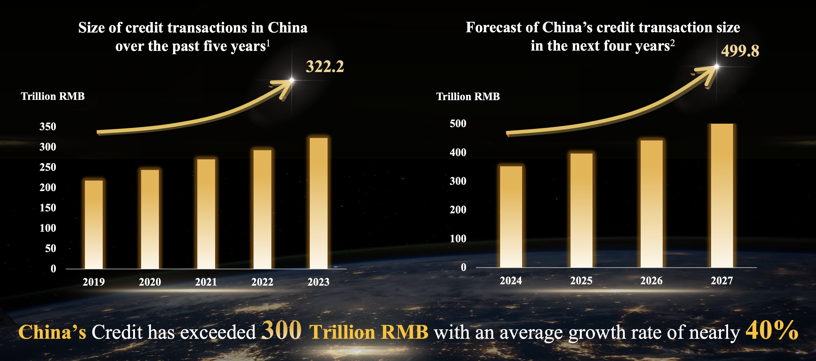

**Figure 1.** China's credit transaction size is growing year on year,

and there is space for higher growth in the future.

* + 1. ***Risk Regulation Becomes Stricter***

In recent years, as China's reform and opening up has entered a deep-water zone, the CPC and the state have attached great importance to the control of financial risks. The Central Economic Work Conference in December 2024 emphasized focusing on the bad debt ratio of small and medium-sized financial institutions to prevent systemic financial risks brought about by the large-scale bankruptcy of small and medium-sized financial institutions. The report to the 20th National Congress of the CPC also emphasized strengthening modern financial supervision and reinforcing the financial stability guarantee system to guard the bottom line against systemic risks.

* + 1. ***Face-to-Face Review is the Crucial Part***

As shown in Figure 2, face-to-face review is an important part of credit approval and risk prevention. It plays an important role in understanding the purpose of borrowing, assessing the amount of borrowing, verifying the application information, and analyzing the repayment ability. If there are problems with the face-to-face review, it is very easy to lead to the wrong issuance of credit, resulting in a higher bad debt ratio and increased risk of bankruptcy.

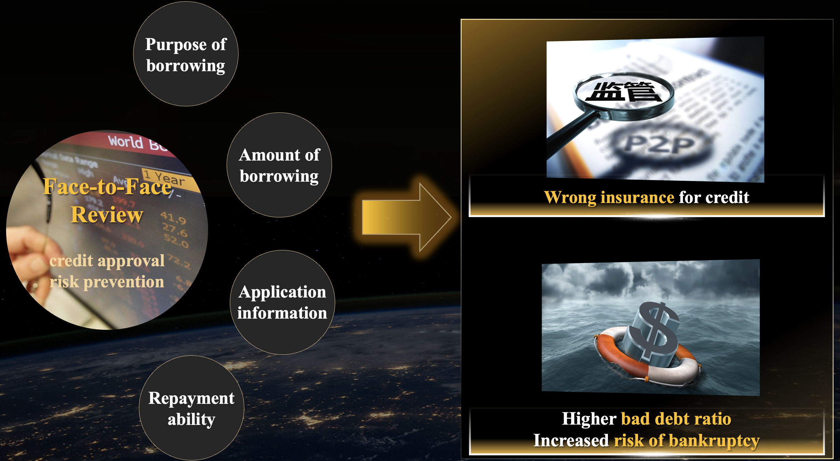

**Figure 2.** The Face-to-Face Review plays a crucial role.

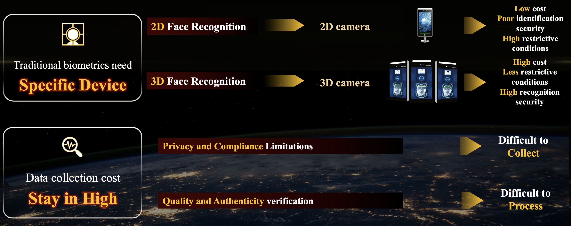

**Figure 3.** Existing technologies are costly to use.



* 1. **Market Pain Points**

In actual face-to-face review scenarios, banks and other lending institutions are also doing their best to optimize the process, but they are still mainly making manual judgments through conversational information. And the mainstream practice in the market faces the following three pain points: 

* + 1. ***Inaccurate***

According to statistics from the China Judgments, the scale of professional loan fraudsters in China is large, and from 2006 to 2023, 63,936 cases of loan fraud have been adjudicated, with the cumulative amount of loans fraudulently obtained exceeding 1,400 billion RMB. The core reason for this misjudgment is the lack of effective technological empowerment in the face-to-face review process. This is on the one hand because the mainstream fraud recognition used by financial institutions generally introduces fewer modalities and incomplete information, resulting in limited accuracy; on the other hand, data imbalance in the credit industry makes it difficult to train risk assessment models (Shen et al., 2020).

* + 1. ***Not Affordable***

The high cost of the technology also discourages many companies from using face-to-face review technology. Traditional biometrics require the procurement of specific equipment, such as a 3D camera, in order to accurately recognize 3D face structures. In addition, the cost of data collection and labeling remains high, mainly due to privacy and compliance constraints, as well as the need to verify the quality and authenticity of the video. More details are in Figure 3.

* + 1. ***Too Slow***

The speed of credit approval is heavily affected by two aspects. The first is the lack of prioritization and urgency in loan approvals. Widespread failure to prioritize and assign urgency to loan approvals by financial institutions allows non-urgent and time-consuming loan approvals to result in long waiting times for subsequent applicants with urgent needs, which in turn results in long average approval times. The second is low real-time data processing speed and integration. Automated approvals require real-time data updating and integration of multiple systems, but the low frequency of data updating and integration of existing products results in insufficiently accurate and real-time data during the approval process, thus affecting the speed of automated approvals.

* 1. **Product Description**

Based on the above analysis, I designed and proposed my product: *Piercing EYE*. Its conceptual diagram is shown in Figure 4. This product piggybacks core **end-to-end algorithms** onto APP and software and analyzes multimodal information data collected by peripheral hardware, such as audio and video, to **provide accurate credit scores for borrowers** undergoing face-to-face reviews and help lenders make rational decisions.



**Figure 4.** The conceptual diagram of my product.

In response to the current market pain points and **to achieve accuracy, low cost, and high speed, my product has been innovatively designed in three main areas.**

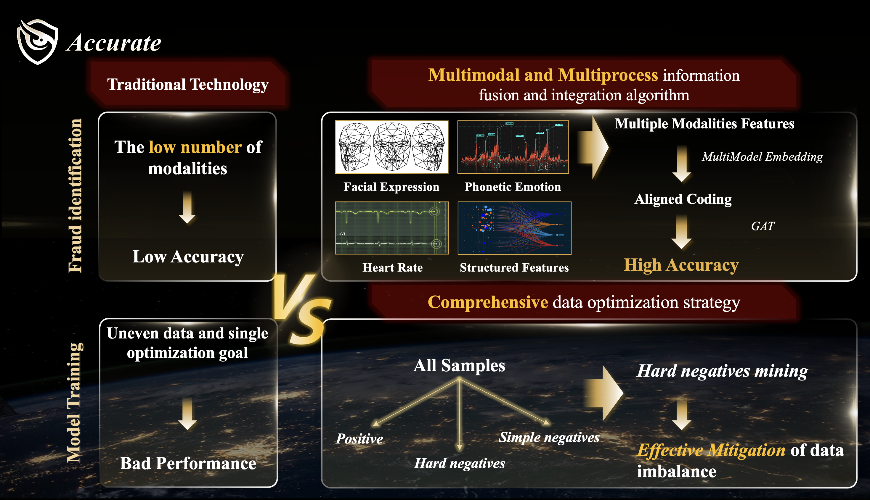

**Figure 5.** The framework of improving accuracy. 

* + 1. ***Improvement of Accuracy***

A framework diagram for improving accuracy is shown in Figure 5. Specifically, new ideas are proposed for data extraction and labeling. Referring to Zhang et al. (2020), I propose a multimodal and multiprocess information fusion and integration algorithm to improve the compre-hensiveness of information collection and the depth of information extraction. It will collect biological information from multiple modalities, such as facial expressions, phonetic emotion, and heart rate. It will use a large model to embed this raw information into a common coding that aligns the data for easy subsequent fusion. The aligned coding is then fed into Graph Attention Networks (GAT) for data integration. GAT is a graph deep learning model that uses an attention mechanism to learn feature representations of nodes in a graph structure (Veličković et al., 2017). It performs aggregation operations on nodes by learning the attention weights between each node and its neighbors. In data integration, GAT can be used to encode graph structures from different data sources and learn the representation vectors of nodes. Then, the node representation vectors from different data sources can be weighted and fused by the attention weights to achieve data integration. Thus, it’s possible to balance the importance of different modal information through attention and thus solve the problem of uneven modal fusion. In addition to this, I constructed a comprehensive data optimization strategy to reduce the imbalance of the data, so as to optimize the training effect of the model. At the core, hard negative sample mining was performed.

* + 1. ***Reduce Costs***

****Based on the pain point analysis, it can be found that the cost of face-to-face review is mainly focused on hardware equipment and data acquisition. From these two perspectives, I first introduced 3D face reconstruction technology (Afzal, H. R. et al., 2020) to get 3D face information through multiple 2D photos, which reduces the cost of data acquisition while ensuring quality. Second, I propose a Contrastive-style Federated Learning (CSTL) approach, which combines contrastive learning (Cui, J. et al. 2021) and federated learning (Li et al. 2021), aiming to solve the problems of data privacy and model performance at the same time. It provides an effective solution to address the balance between data privacy and model performance. In contrastive federated learning, each local device or data center has its dataset and uses contrastive learning to extract feature representations of the local data. Contrastive learning learns the similarities and differences between samples by comparing different views of the same sample. This enables the model to

learn more discriminative feature representations. These local devices will then use the feature representations obtained from contrast learning to perform model aggregation and updating using federated learning. During the process of federated learning, the local devices only need to transmit the parameters of the local model to the central server without uploading the raw data. The central server performs model aggregation and updating based on the received parameters and sends the updated global model back to the local devices. The framework is in Figure 6.

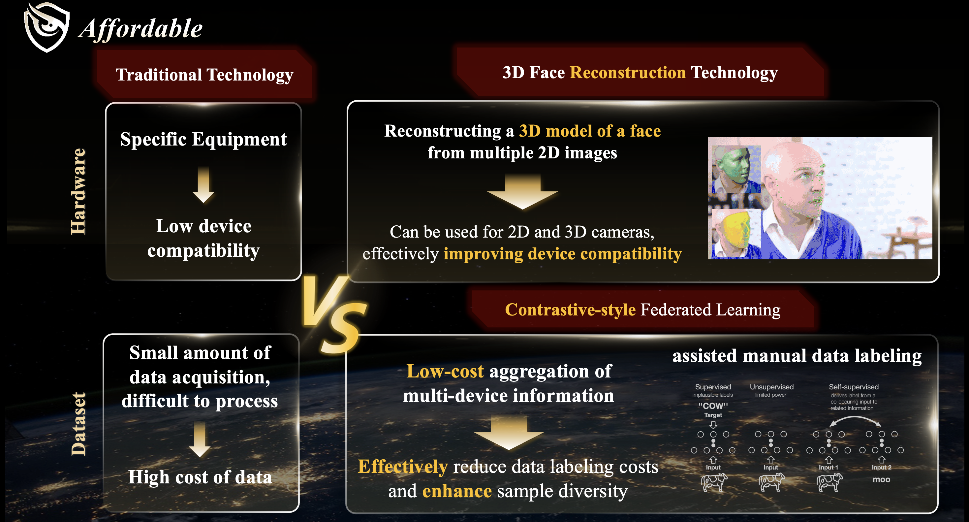

**Figure 6.** The framework of reducing costs.

* + 1. ***Accelerated approval***

Unlike the traditional sequential priority approval, I have introduced an approval response ratio in the product, which comprehensively analyzes multiple dimensions such as loan size, urgency, waiting time, and expected approval time to get an all-around evaluation index. By prioritizing the approval of loans with high response ratios, the average approval time can be effectively reduced. In the traditional approval process, if you want to update the auxiliary model, you need to upload all the data, so the updating efficiency is extremely low. However, my built cloud collaboration database supports online learning without the need to re-upload all data and reduces communication delays with cloud computing centers. These two designs achieve greater optimization in terms of approval process design and specific systems that can make approvals more efficient.



**Ⅱ. Business Analysis**

After detailing my proposed product and market background, here I will briefly conduct a business analysis. The main focus will be on **competitor analysis, business models.**

* 1. **Competitors Analysis**

I collected information about domestic competitors and analyzed them from 3 perspectives: recognition method, amount of local data required, and price. The results are shown in Figure 7. It can be seen that my proposed product is more diversified in modality, more favorable in price, and more reliable in effect in the future, and achieves all-round transcendence!

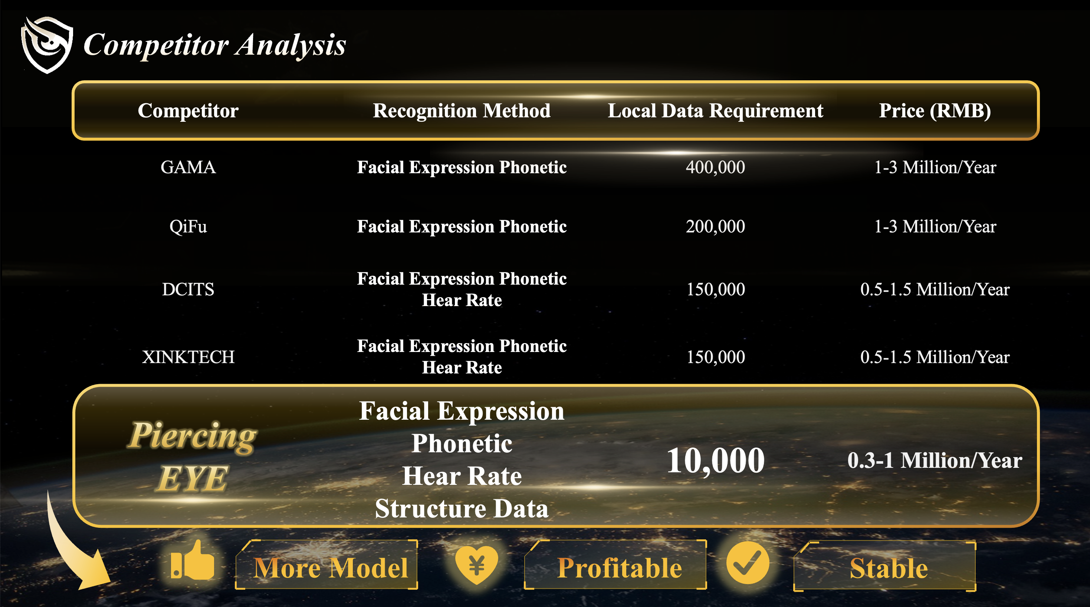

**Figure 7.** The result of Competitors Analysis.

* 1. **Business Model**

I present the operating model for this product in Figure 8. In general, the first step is to set up a research laboratory with an individual as the main body to develop the idea to the ground. Secondly, a company is established while the technology is being developed, and negotiations for cooperation are started. After the company is established, it independently sells to banks and other companies that have a need for lending business. Our main profitability is based on software development and sales, with the addition of technical services and customized programs.



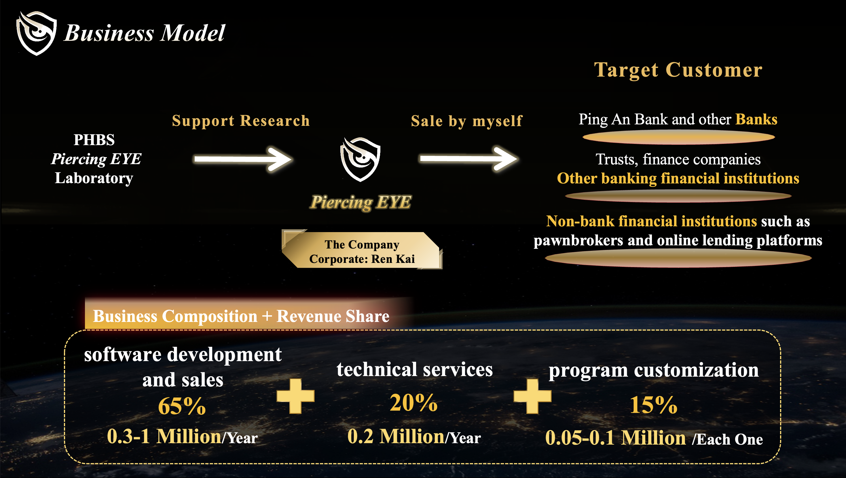

**Figure 8.** The business model.

Overall, in this business proposal, I designed an accurate, profitable, and efficient credit checking tool - Piercing EYE - for the face-to-face review segment of the credit scenario. Above, I've summarized the pain points in this area more comprehensively, as well as the specific solutions for this product. With the rapid development of fintech, the improvement of financial services, and the expansion of credit, there is a great deal of room for the use of this tool in the future!



**References**

Shen, F., Liu, Y., Wang, R., & Zhou, W. (2020). A dynamic financial distress forecast model with multiple forecast results under unbalanced data environment. *Knowledge-Based Systems*, *192*, 105365. <https://doi.org/10.1016/j.knosys.2019.105365>

Zhang, C., Yang, Z., He, X., & Deng, L. (2020). Multimodal intelligence: Representation learning, information fusion, and applications. *IEEE Journal of Selected Topics in Signal Processing*, *14*(3), 478-493. <https://ieeexplore.ieee.org/abstract/document/9068414>

Veličković, P., Cucurull, G., Casanova, A., Romero, A., Lio, P., & Bengio, Y. (2017). Graph attention networks. *arXiv preprint arXiv:1710.10903*. <https://arxiv.org/abs/1710.10903>

Afzal, H. R., Luo, S., Afzal, M. K., Chaudhary, G., Khari, M., & Kumar, S. A. (2020). 3D face reconstruction from single 2D image using distinctive features. *IEEE Access*, *8*, 180681-180689. <https://ieeexplore.ieee.org/abstract/document/9210569>

Cui, J., Zhong, Z., Liu, S., Yu, B., & Jia, J. (2021). Parametric contrastive learning. In *Proceedings of the IEEE/CVF international conference on computer vision*. <https://arxiv.org/abs/2107.12028>

Li, Q., He, B., & Song, D. (2021). Model-contrastive federated learning. In *Proceedings of the IEEE/CVF conference on computer vision and pattern recognition*. <https://arxiv.org/abs/2103.16257>

1. http://www.pbc.gov.cn/diaochatongjisi/116219/116319/index.html
2. https://www.ceicdata.com.cn/zh-hans/indicator/china/domestic-credit-growth